To test my program, Please follow the instruction: please try to run my program on visual studio rather than the runbat,

First, run Pr4YYE.sln, it will show like this: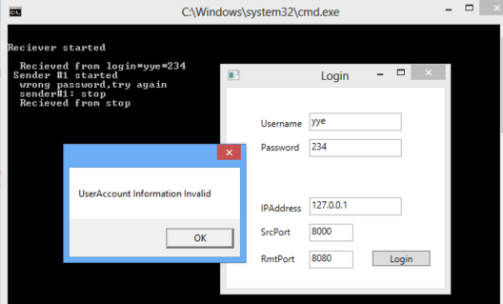

Change to right password, it successfully go into the second window, as shown below.

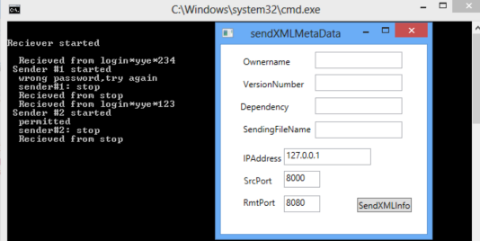

Second: trying to send xmlMetaData:

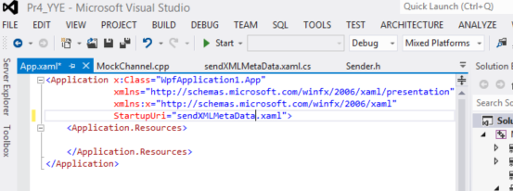

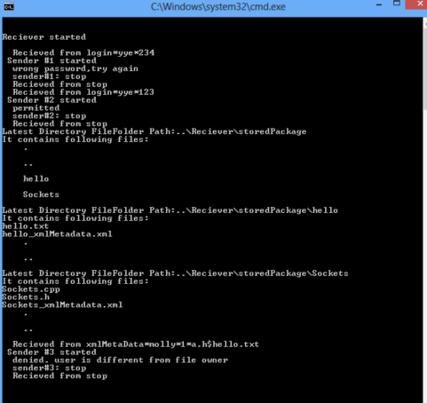

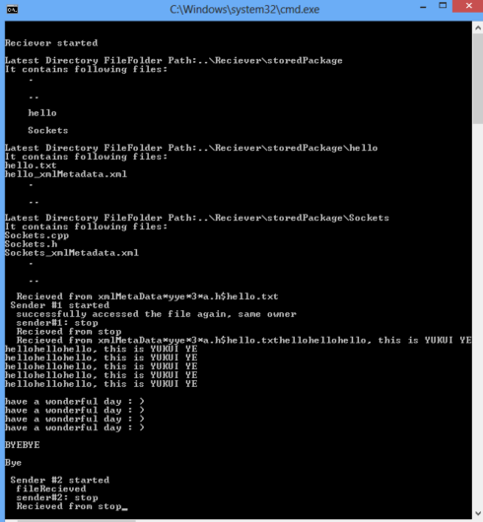

CHECK WHETHER USER NAME IS SAME AS FILE’ OWNER’S NAME

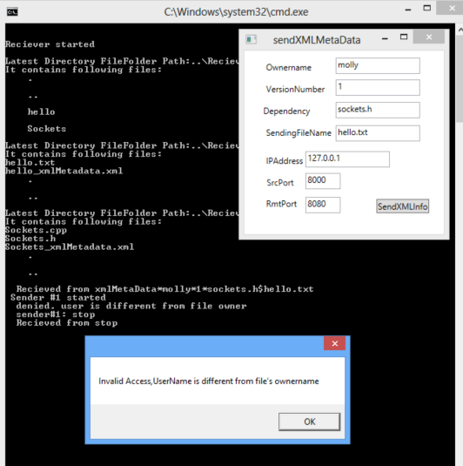

WHEN CORRECT THE USERNAME SAME AS THE FILE’S OWNER NAME, IT SUCCESSFULLY GOES INTO NEXT WINDOW, AS SHOWN BELOW;

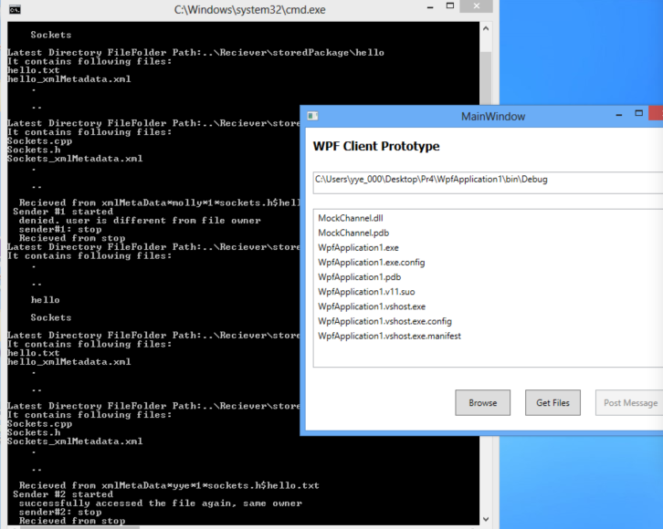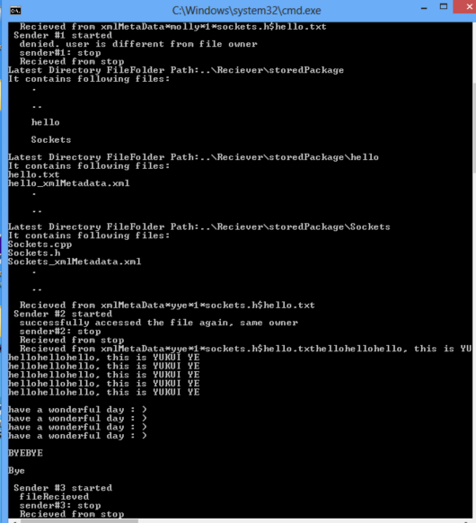

although it crashed at the last minute, but it complete all the requirement, it successfully stored the files information and create its xml file , and it successfully create folder for each file and stored the file in that folder. All the relative validation code in receiver.cpp